Safeguarding Arrangements

Effective: September 2022
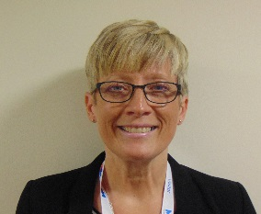  Jayne Griffiths  Designated Safeguarding Lead |  | 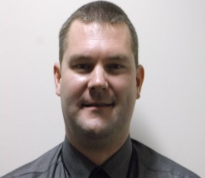  Spencer Wigley Deputy Designated  Safeguarding Lead | 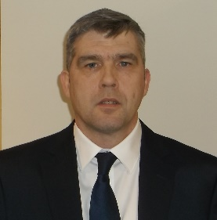 Andy Hunter  Safeguarding Lead | 0121 344 7999  0121 344 7912 or 0121 331 3944
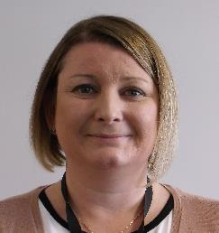  Rhonda Hannon  Safeguarding Lead | 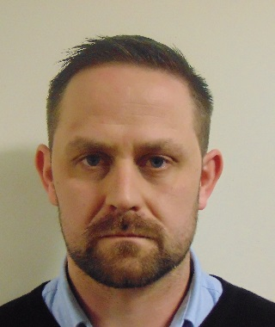  Daniel Stokes  Safeguarding Lead |  | 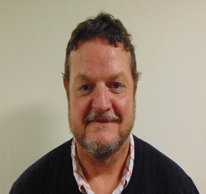  Vincent Edwards  Safeguarding Lead | 0121 344 7999  0121 344 7912 or 0121 331 3944
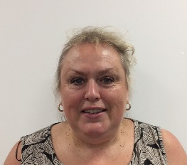  Yasmin Prescott  Safeguarding Lead | Simon Powell  Safeguarding Lead |  |   Olu Olatayo-Moses  Safeguarding Lead | 0121 344 7999  0121 344 7912 or 0121 331 3944
Nicholas Andrews  Safeguarding Lead |   Neil Ellor  Safeguarding Lead |  |   Michelle Owens  Safeguarding Lead | 0121 344 7999  0121 344 7912 or 0121 331 3944

