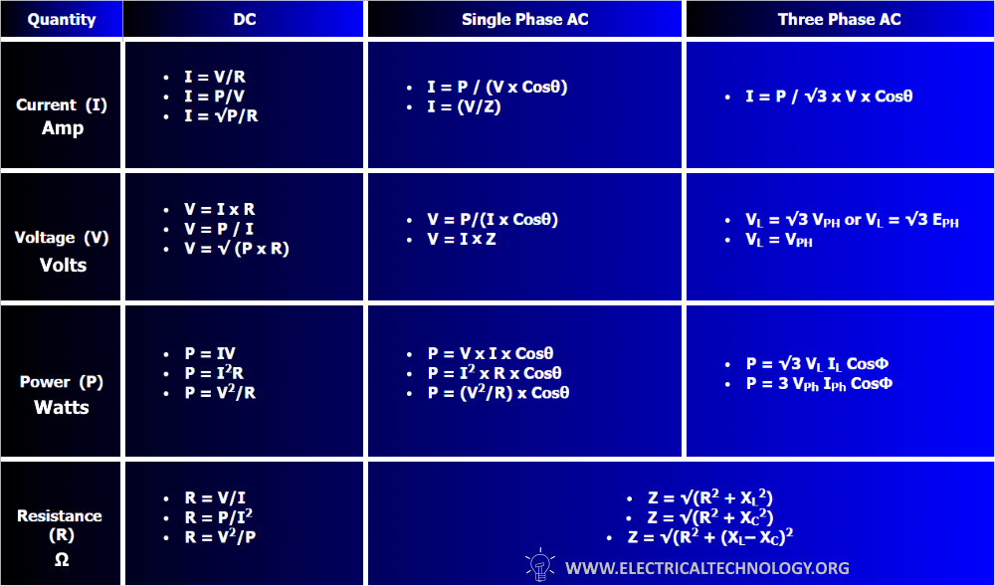

Electrical Current Formulas
Electrical Current Formulas in DC Circuit
- I = V/R
- I = P/V
- I = √P/R
Electrical Current Formulas in Single Phase AC Circuit
- I = P / (V x Cosθ)
- I = (V/Z)
Electrical Current Formulas in Three Phase AC Circuit
- I = P / √3 x V x Cosθ

Voltage or Electrical Potential Formulas
Electrical Potential or Voltage Formula in DC Circuits
- V = I x R
- V = P / I
- V = √ (P x R)
Voltage or Electrical Potential Formulas in Single Phase AC Circuits
- V = P/(I x Cosθ)
- V = I x Z
Voltage Formulas in Three Phase AC Circuits
- V_{L} = √3 V_{PH} or V_{L} = √3 E_{PH} … [Star Connection]
- V_{L} = V_{PH} … [Delta Connection]

Electric Power Formulas
Power Formulas in DC Circuits
- P = V x I
- P = I² x R
- P = V²/R
Power Formulas in Single Phase AC Circuits
- P = V x I Cosθ
- P = I² x R Cosθ
- P = (V²/R) Cosθ
Power Formulas in Three Phase AC Circuits
- P = √3 x V_{L} x I_{L} Cosθ
- P = 3 x V_{P} x I_{P} Cosθ

Electrical Resistance Formulas
Electrical Resistance & Impedance Formulas in DC Circuits
- R = V/I
- R = P/I²
- R = V²/P
Electrical Resistance & Impedance Formulas in AC Circuits
In AC Circuits (capacitive or inductive load), Resistance = Impedance i.e., R = Z
- Z² = R² + X² … In case of resistance and reactance
- Z = √(R² + X_{L}²) … In case of Inductive load
- Z = √(R² + X_{C}²) … In case of Capacitive load
- Z = √(R² + (X_{L}– X_{C})²… In case of both inductive and capacitive loads.
Impedance is the resistance of AC circuits i.e. resistive, captative and inductive circuit (already mentioned above). Where “Z” is the impedance in ohms, “R” is resistance in Ohms and “X” is the reactances in Ohms.
Good to know:
- I = Current in Amperes (A)
- V = Voltage in Volts (V)
- P = Power in Watts (W)
- R = Resistance in Ohm (Ω)
- Z = impedance = Resistance of AC Circuits in Ohms
- Cosθ = Power factor = Phase difference between voltage and current in AC circuits
- V_{PH} = Phase Voltage
- V_{L} = Line Voltage
Also,
X_{L} = Inductive reactance
X_{L} = 2πfL…Where L = Inductance in Henry
And;
X_{C} = Capacitive reactance
X_{C} = 1/2πfC… Where C = Capacitance in Farads.
Also, ω = 2πf
[/box]
The following table shows the current, voltage, power and resistance equations and formulas in DC and 1-Φ & 3-Φ AC circuits.
Quantity | DC | Single Phase AC | Three Phase AC
Current  (I) | - I = V/R  - I = P/V  - I = √P/R | - I = P / (V x Cosθ)  - I = (V/Z) | - I = P / √3 x V x Cosθ
Voltage  (V) | - V = I x R  - V = P / I  - V = √ (P x R) | - V = P/(I x Cosθ)  - V = I / Z | - V_{L} = √3 V_{PH} or V_{L} = √3 E_{PH}  - V_{L} = V_{PH}
Power  (P) | - P = IV  - P = I²R  - P = V²/R | - P = V x I x Cosθ  - P = I² x R x Cosθ  - P = (V²/R) x Cosθ | - P = √3 V_{L} I_{L} CosФ  - P = 3 V_{Ph} I_{Ph} CosФ
Resistance  (R) | - R = V/I  - R = P/I²  - R = V²/P | - Z = √(R² + X_{L}²)  - Z = √(R² + X_{C}²)  - Z = √(R² + (X_{L}– X_{C})²

Other Additional Electrical Quantities Formulas
Conductance:
G = 1 / R
It is the reciprocal (i.e. inverse) of resistance. The unit of conductance is Siemen or Mho and represented by the symbol of “G” or “℧”.
Capacitance:
C = Q / V
Where “C” is capacitance in farads, “Q” is charge in coulombs, and “V” is voltage in volts. The unit of capacitance is Farad “F” or microfarad “μF”.
Inductance:
V_{L} = -L (di / dt)
Where “L” is inductance in Henrys, “V_{L}” is the instantaneous voltage across the inductor in volts and “di/dt” is the rate of changes in current in Amperes per second. The unit of Inductance “L” is Henrys “H”. It is also known as Ohm’s law for inductance.
Charge:
Q = C x V
Where “Q” is the charge in coulombs, “C” is the capacitance in farads and “V” is the voltage in Volts.
Frequency:
f = 1 / T
Time Period
T = 1 / f
Where “f” is frequency in Hertz (Hz) and “T” is the time periods in seconds.
Related Posts:

Trigonometry

