Instructions for getting a turnitin account

Go to website www.turnitinuk.com
The screen should look something like this
Pick on Create account in the top right hand corner
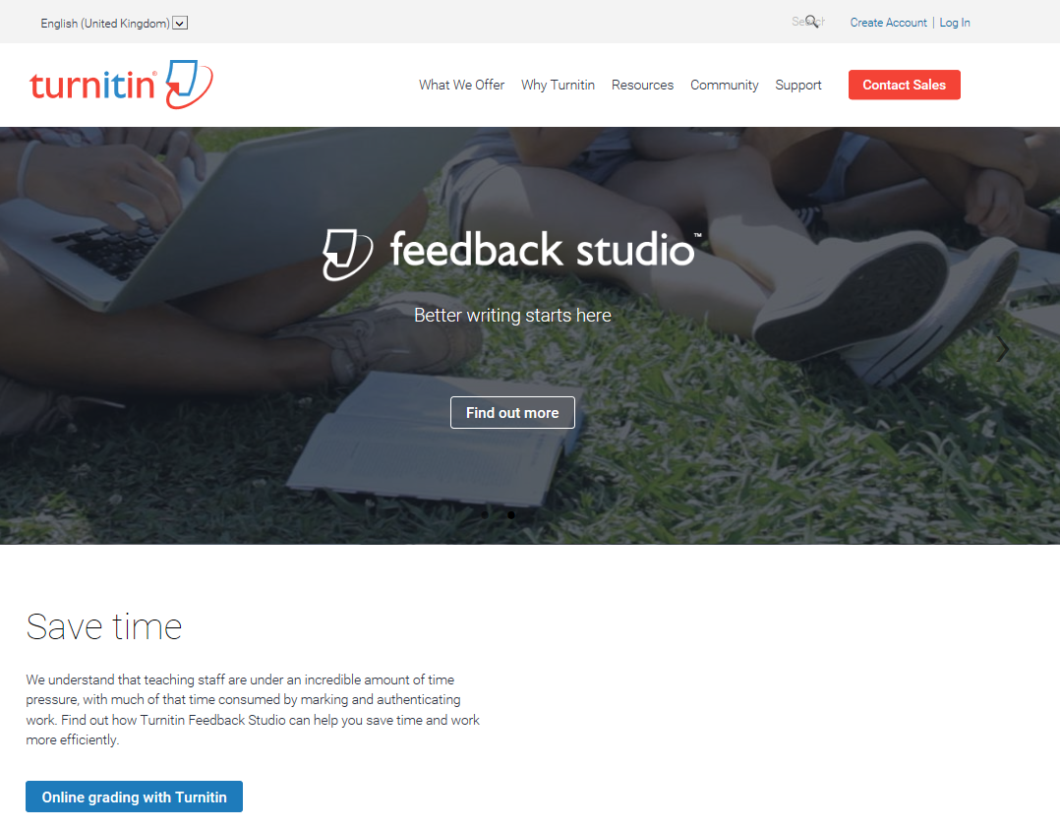
You should then get the screen below. DO NOT enter any details just pick student
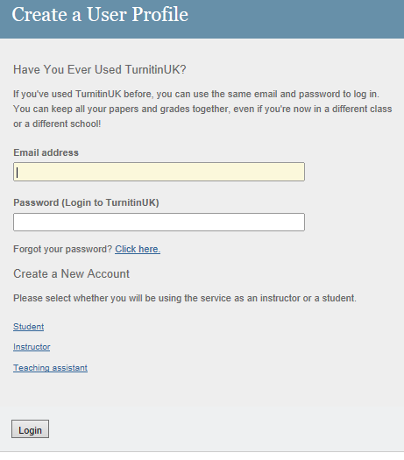
Please then enter all the details requested. You will need:-
Class ID: you will need to get this from your tutor
Class enrolment password: again you will need to get this from your tutor

