
A Guide to Apprenticeship Standards
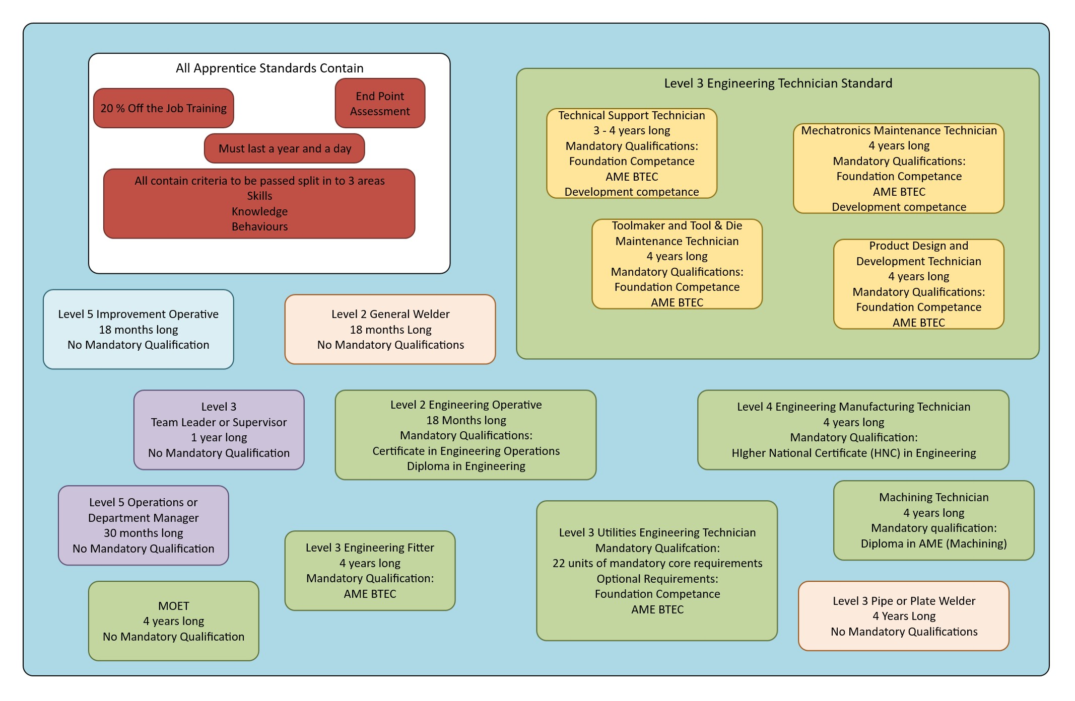
Level 3 Engineering Example Timeline
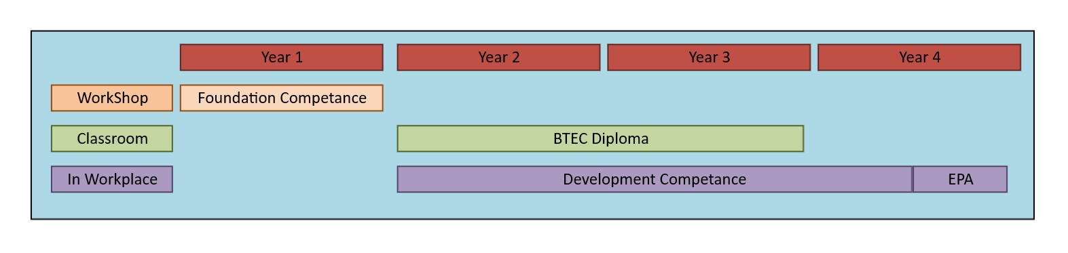
Standards can be found at; Apprenticeship standards / Institute for Apprenticeships and Technical Education
Knowledge, Skills and Behaviours; These are the 3 areas of an apprenticeship that must be achieved. Knowledge is the theory required, Skills are the practical skills needed to be achieved, and these are different for each apprenticeship. Behaviours are similar in all apprenticeships and are the life skills you need to be a good employee, such as communication, working in teams and safe working amongst others.
End Point Assessment (EPA); This is the assessment at the end of the apprenticeship, it contains various elements dependent on the apprenticeship, such as practical observations, interviews with a specialist assessor, portfolio of work or a presentation. The EPA is the last part of the apprenticeship, when passed the apprenticeship is complete.
BTEC Advanced Manufacturing Engineering Diploma; A technical certificate containing 11 or 12 units taught in the classroom on a day release in year 1 and either week release or day release on year 2. Year 1 units include Maths, Electrical and Mechanical science, Engineering Drawing and Health and Safety. Year 2 contains a project and 4 other subjects relevant to the apprenticeship. There are various combinations of units, dependant on the course and company requirements. Specification
Foundation Competence; 10 units completed in the centre in the workshop. 3 are paperwork units completed in tutorials and apprentice’s own time. 7 units are practical units. All do Lean plus 6 others dependant on their apprenticeship. Units include subjects like Bench, Machining, Fluid power, CAD, Maintenance, Electrical as well as other areas. Specification
Development Competence; The qualification carried out whilst at work during the 2 – 4 years of the apprenticeship. It contains a number of units some mandatory and some optional, all based on the work the apprentice does in their workplace. For an example see Specification though this is different for each pathway.
Higher National Certificate in Engineering (HNC); The technical certificate for the Engineering Manufacturing Technician, this qualification is also offered as a stand-alone Level 4 qualification. It is a 2-year day release program with 3 pathways: Electrical/Electronic, Mechanical and Manufacturing. Each pathway has 8 units with both mandatory and optional units. Year 1 is the same for all the pathways with year 2 containing a project and specialist units Specification
L2 Certificate in Engineering Operations and Diploma in Engineering; The Certificate in Engineering Operations is the technical certificate in the level 2 engineering operative apprenticeship, this is taught on the shop floor alongside the Diploma in Engineering which is the practical qualification the diploma is a shortened version of the foundation competence with 7 units instead of 10. Certificate in Engineering Operations Specification and Diploma in Engineering Specification
Diploma in Machining: The qualification attached to the Machining Technician standard it contains both practical (1st Year) and classroom (2nd & 3rd year) units. Specification

