Turnitin Guide for Teachers
From September 2020 all Turnitin assignments for Further Education and Higher Education Technical Certificate (Classroom) qualifications will be created on the TurnitinUK website not via Moodle.
This can be accessed at https://www.turnitinuk.com/ or via the link in the panel on the right side of Moodle:
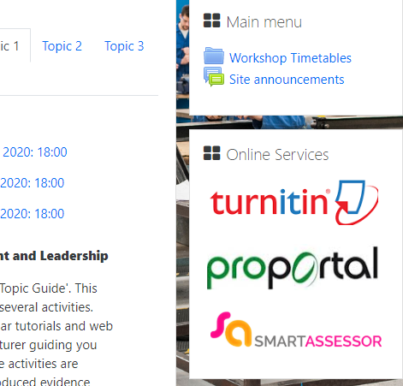

Accessing Classes
- Once you have logged in go to the qualification you are delivering e.g. BTEC
- The classes you are assigned to will be listed. You do not need to Add Classes. These will be created and allocated to you.
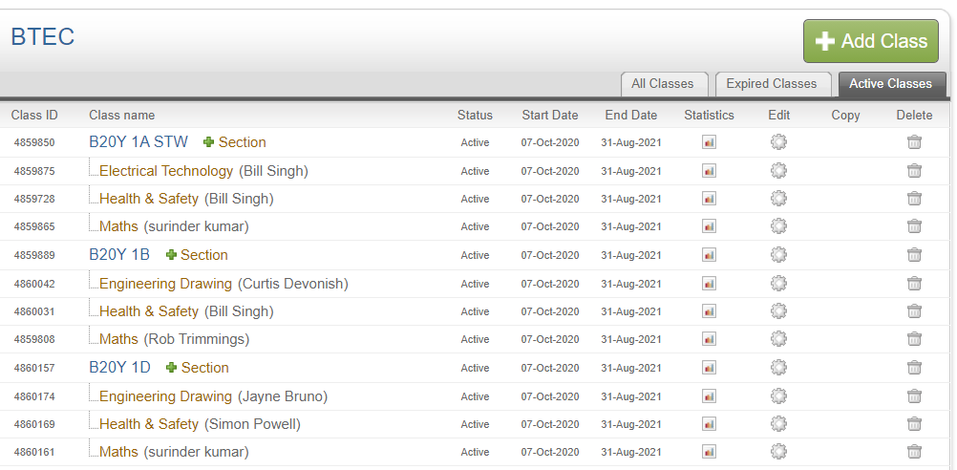
- Click on a subject you are delivering e.g. Electrical Technology
- You can now create assignments for your learners by clicking on Add Assignment. These can simply be called Assignment 1, Assignment 2 etc. See the creating Turnitin Assignment guide below for further details
- Your students will only be able to access the class and assignments once they have enrolled using the Class ID and Enrolment Key. This will be sent to you in a separate file and you will need to issue these directly to your learners.
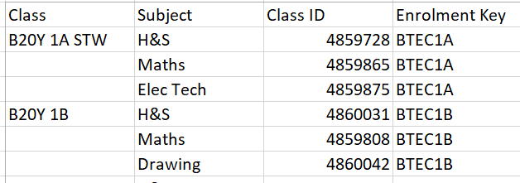

Setting up Assignments
Once you have clicked on Add Assignment, set up the assignment as follows:
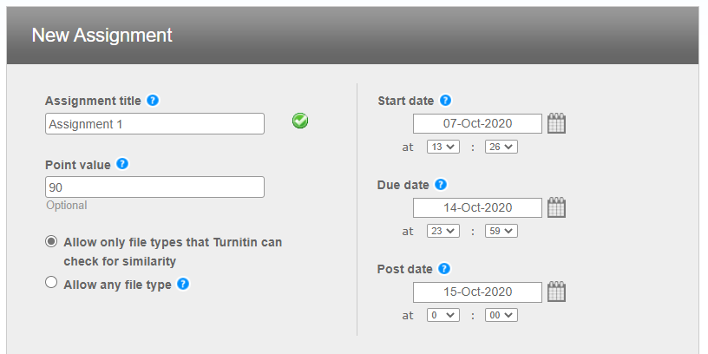
- Assignment title should be Assignment 1, Assignment 2 etc.
- Point value – the maximum grade possible for the assignment
  - Pass – 70
  - Merit – 80
  - Distinction – 90
- The Post date means that students can’t see assignment grades until this date.
- Under Optional Settings, set as below
- Submit the assignment. The students should now be able to access this as long as they have enrolled correctly in the class.

Optional Settings
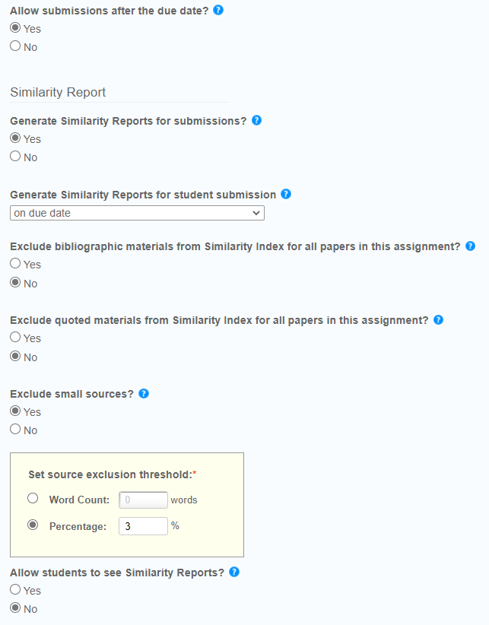 | 