How to Access Your Online Classroom!

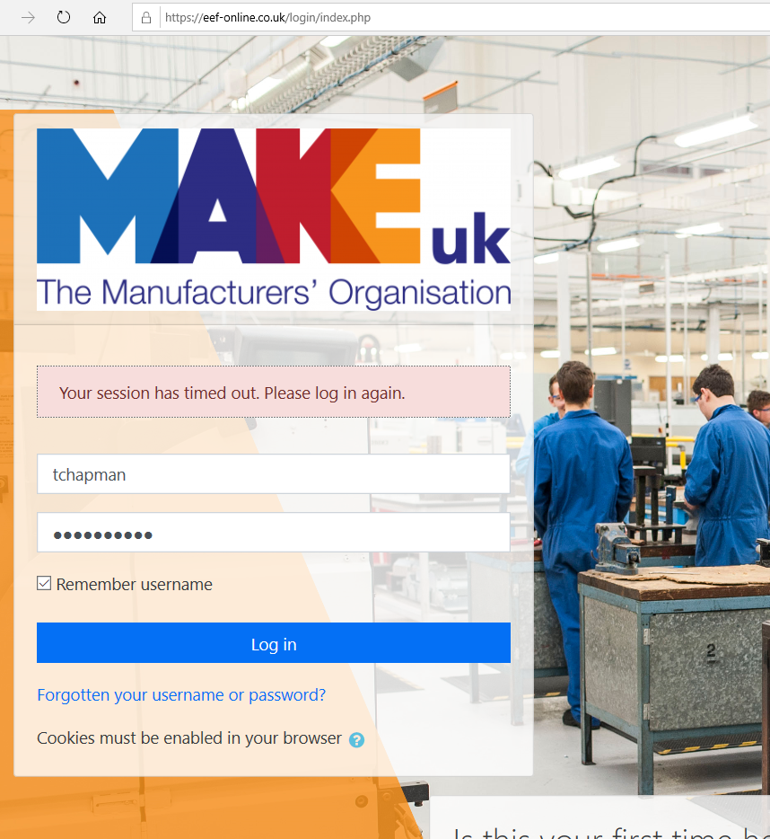

Log on to your Moodle Account.

Please use either Google Chrome, Firefox or Edge Chromium.

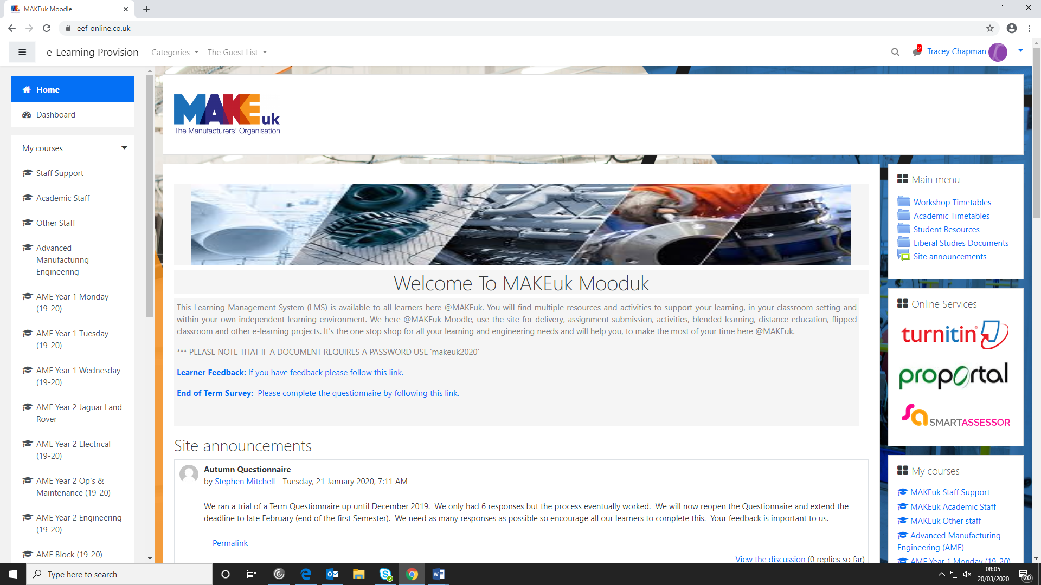

Go to the course that you are currently enrolled on which you would find here.

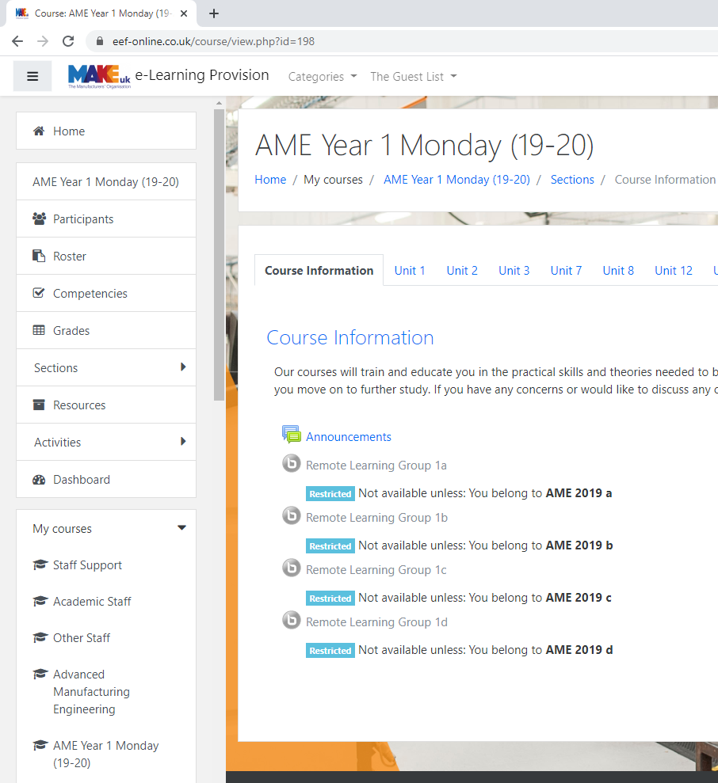
Once you click on your course, on the course information tab you will see this screen, click on the remote learning group that is yours, for example: Remote learning group 1A

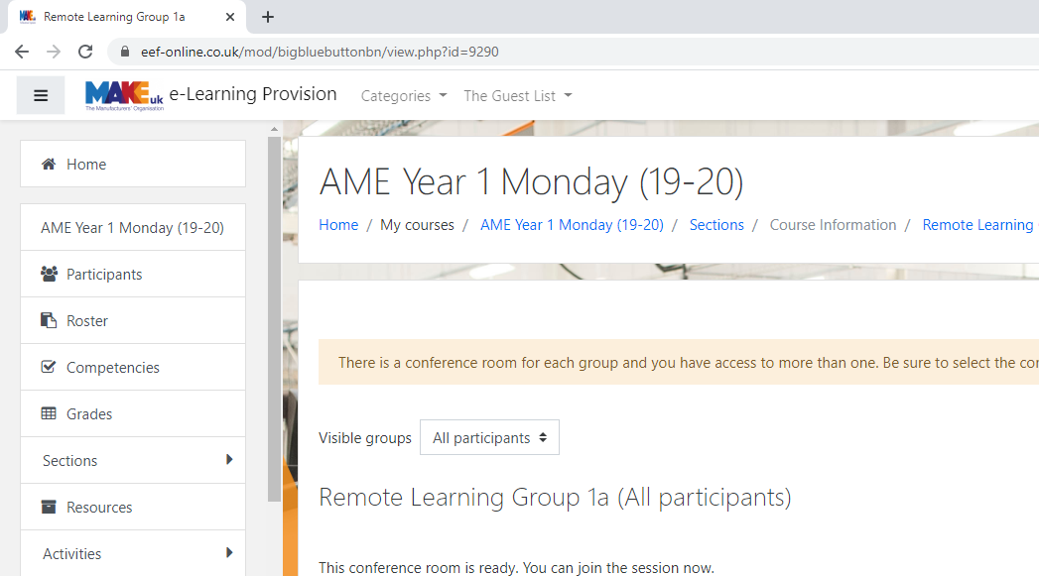
Where it says visible groups, select your group. E.G. AME 2019 A.

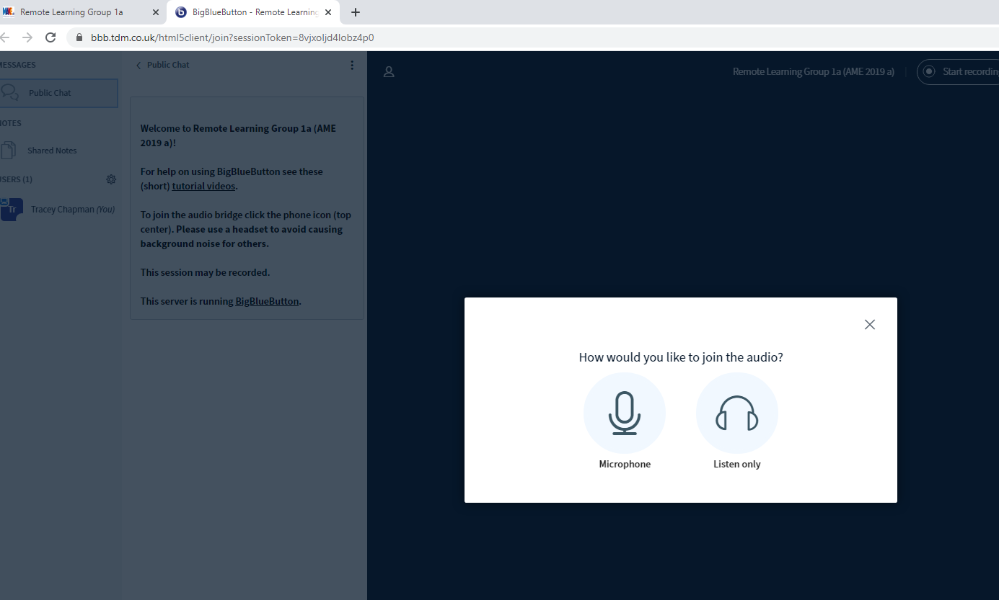
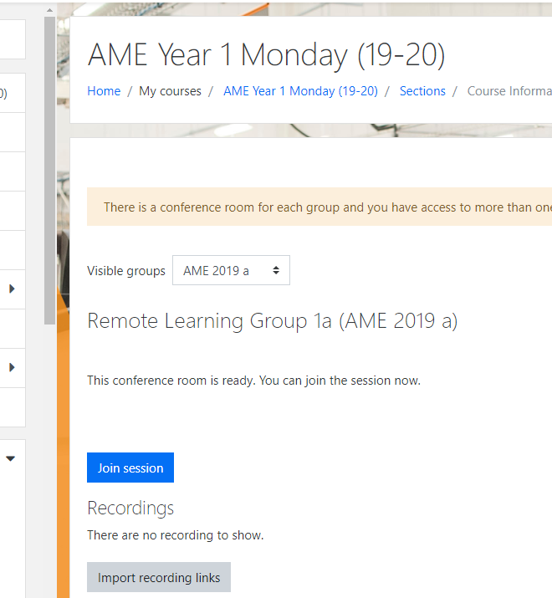
Once you have followed the above steps click on Join session.

You will then be taken to this tab. Please click on Microphone.
- This does mean that you will need a microphone/headset with a built in microphone.

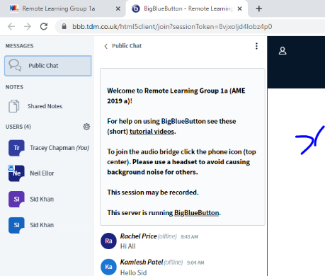
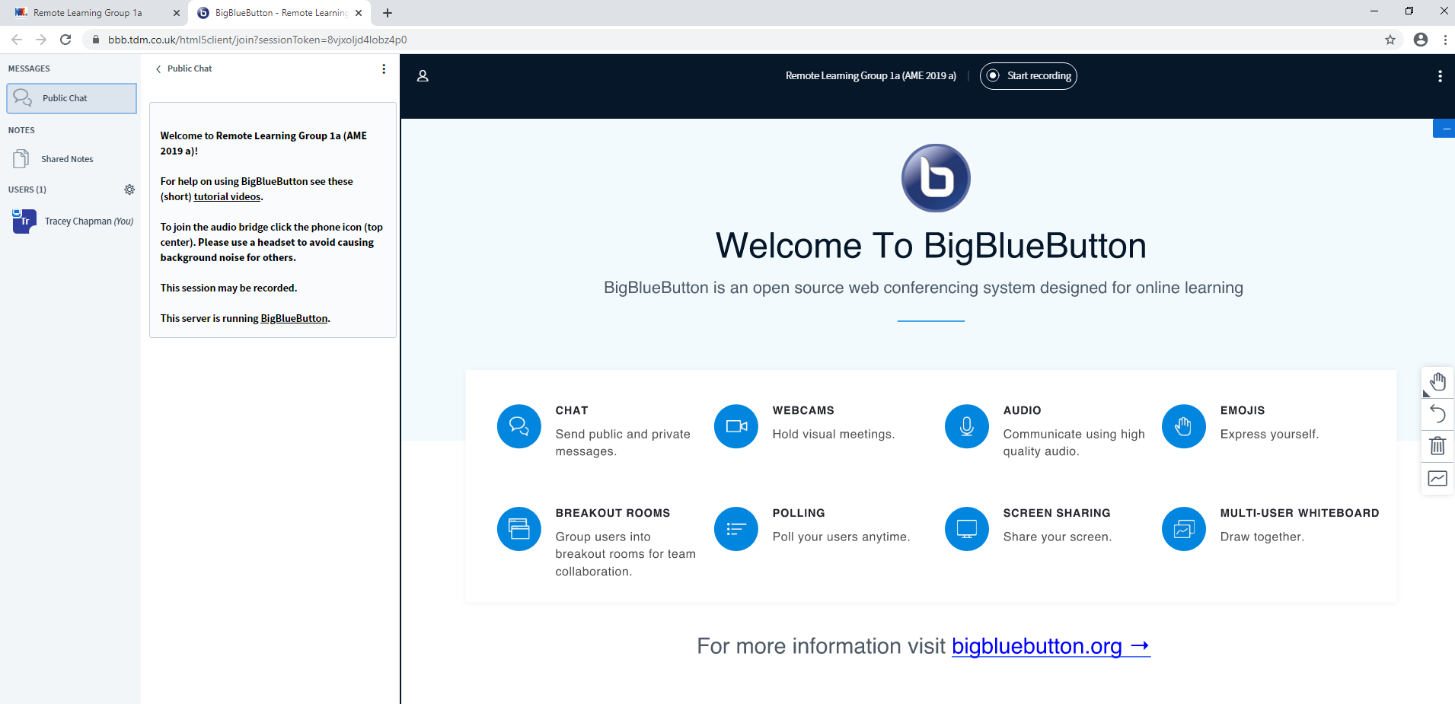
Please click the link to watch the video for learners.
However if you require any support please contact:
tchapman@makeuk.org or skhan1@makeuk.org
You will then see this.
Your tutor will be waiting on you to join since your attendance it registered and fed back to your company.
It is Mandatory that you are present.

