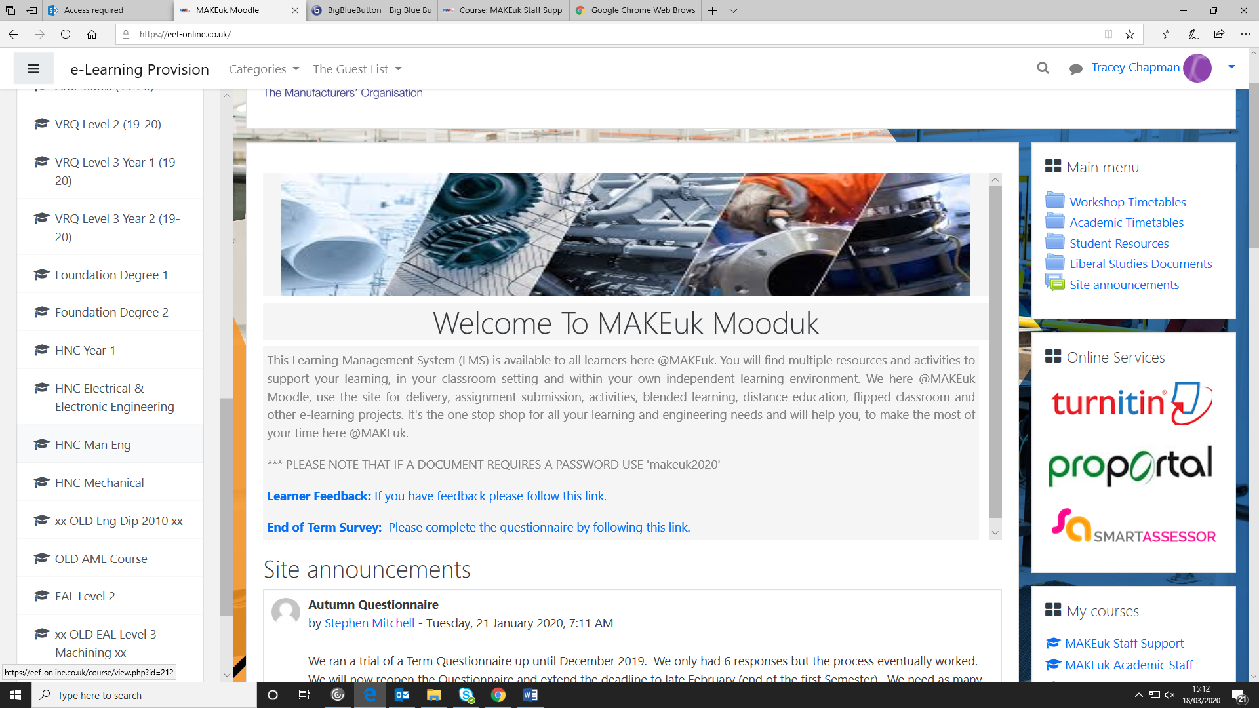
On the left hand side of the home page, scroll down until you get
To the relevant course page you are teaching and click on it.

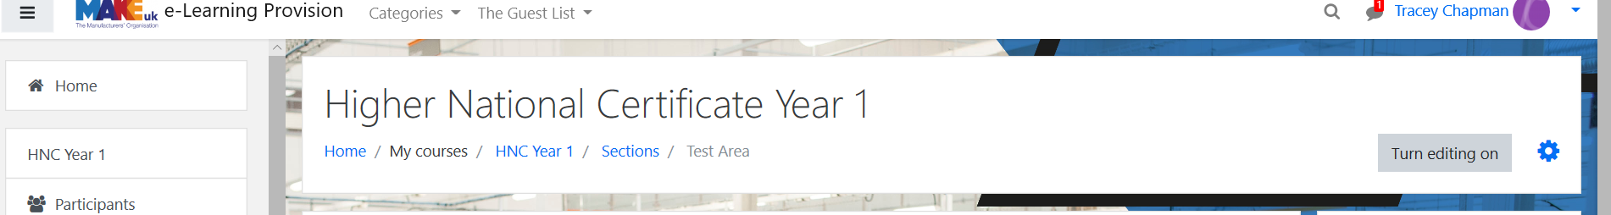
Click on “Turn Editing On”

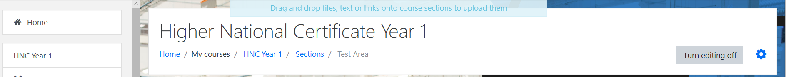
Once you have turned the editing on click the settings icon next to it
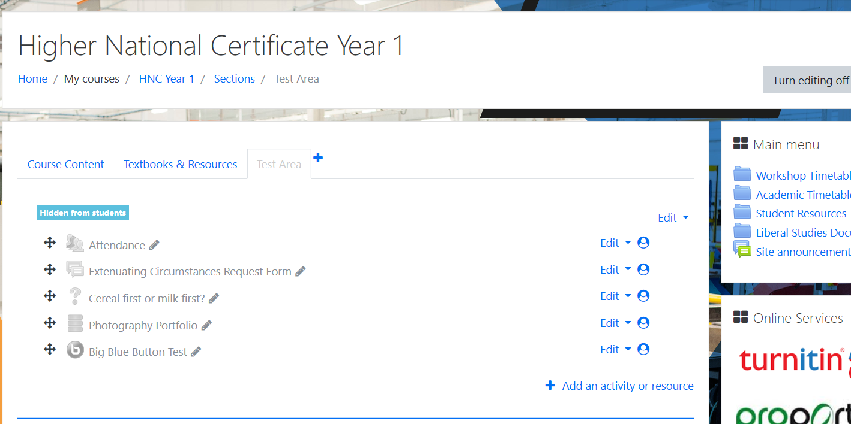

Once you have done this, you will be presented with this page.
Clock on the “Add an activity or resource”

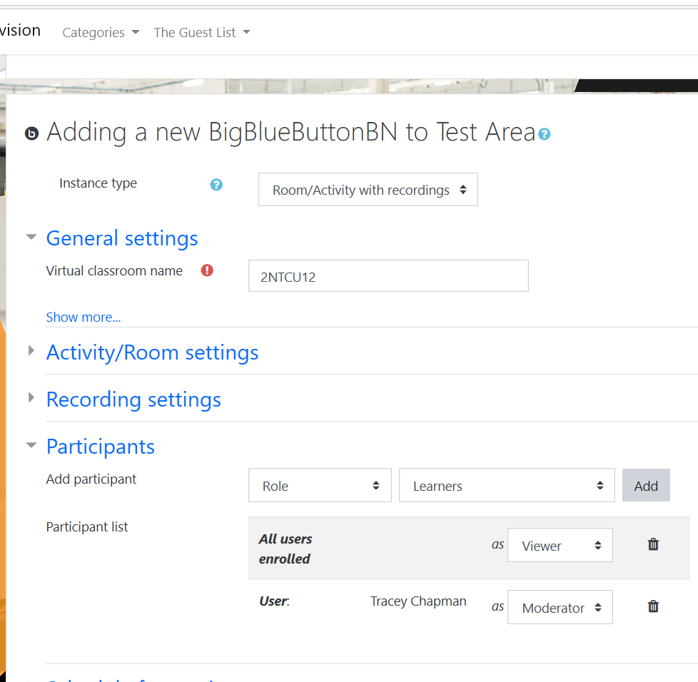
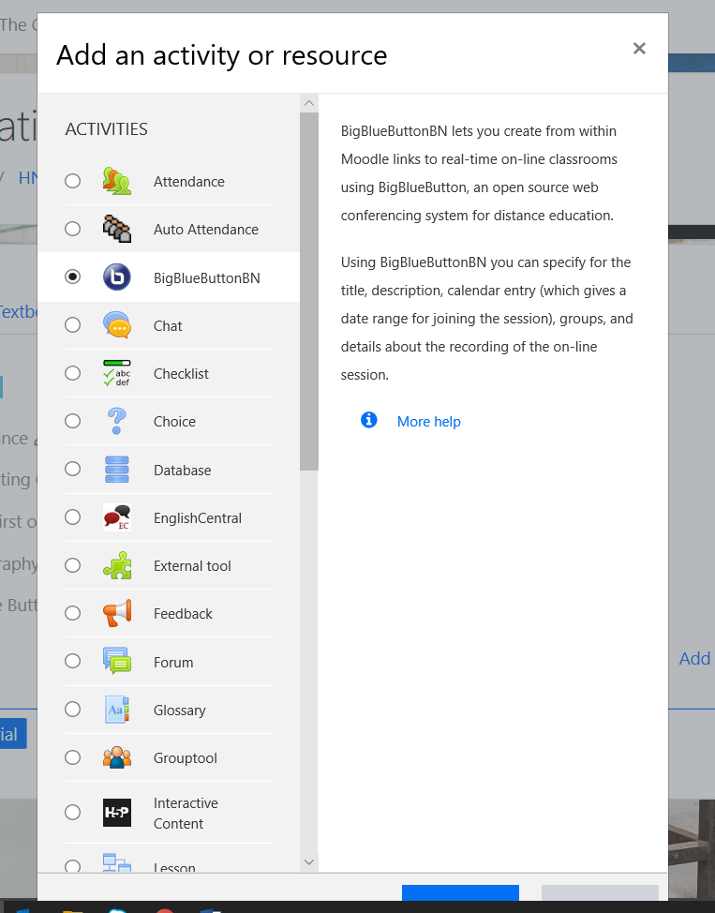
RemotelearningGroupJ
Once you get to this page you will need to add a virtual classroom name, this must include the following:
- RemoteLearning
- Group name
See below for an example.
You will be presented with this page.
- Select the big blue button
- Click on add
After you have added the classroom name, go to Participants.
Delete “All users enrolled”
Select “Role” and then “Learners” and click “Add.” Ensure they are selected as a VIEWER!
To add a moderator it is the same steps but instead of role it is User, their name and select moderator instead of viewer.

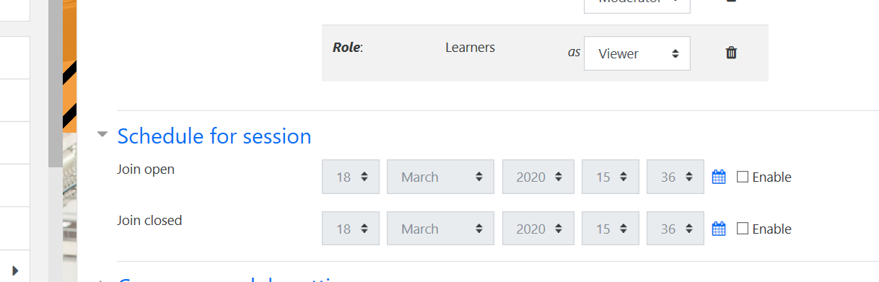
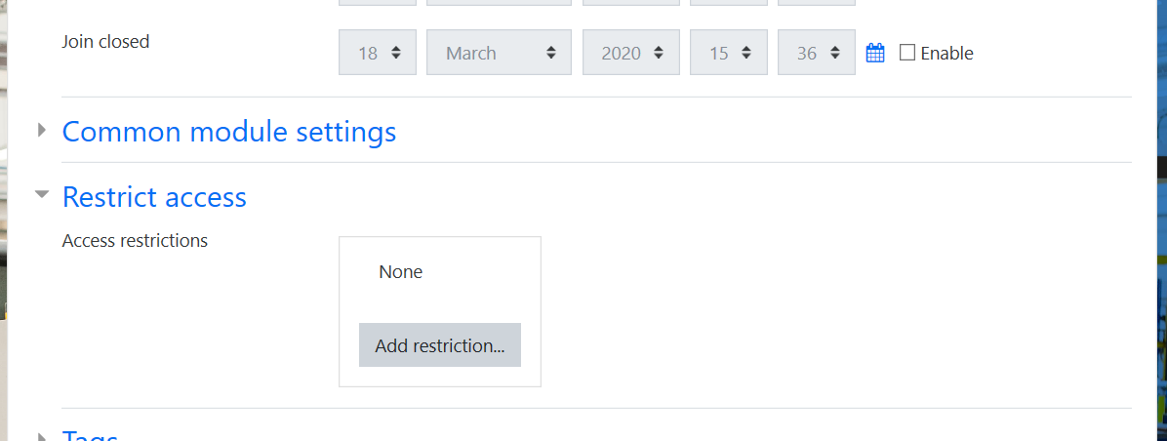
Select “Restrict Access” and then click on Add restrictions.
Select “schedule for session” add in the following:
- Date and time they need to join
- Date and time the session is over
Make sure you tick ENABLE beforehand.

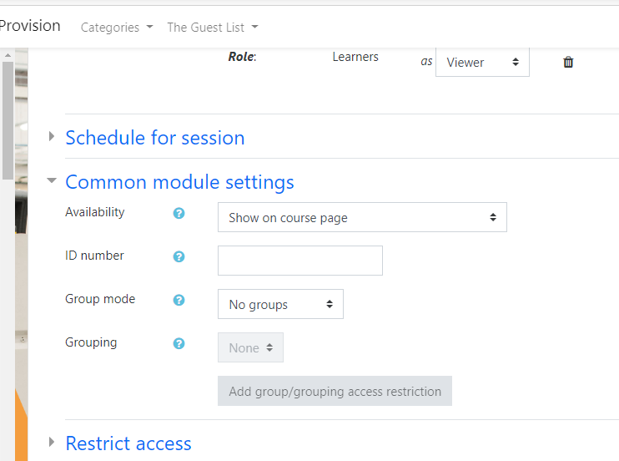
Click on the “common module settings” tab.
Where it says group mode ensure it says NO GROUPS.

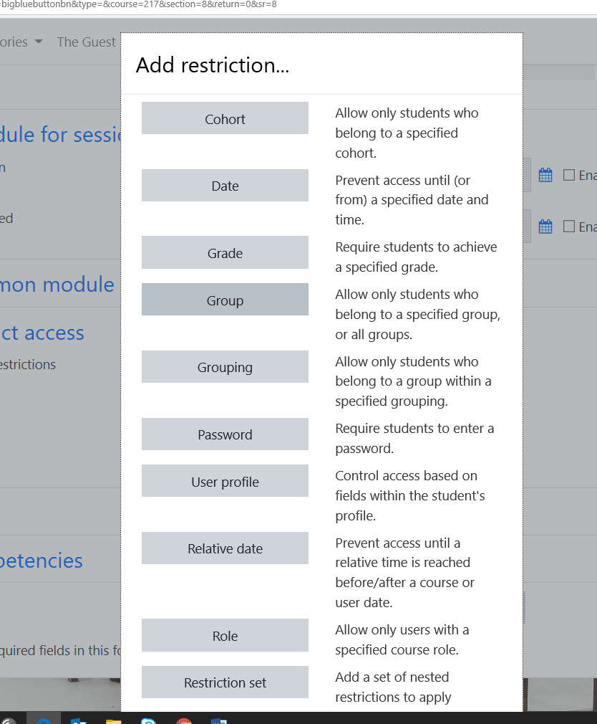
Once you have got to this page, select GROUP.

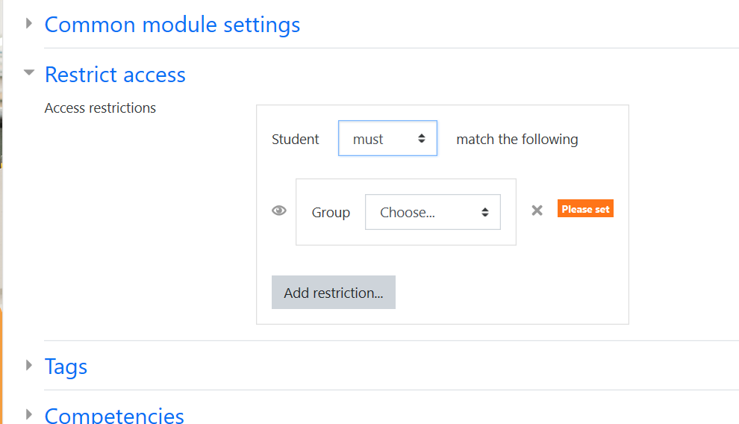

Once you have selected “Group” you will be shown this.
You select “Must” and then the group you require to attend.

(Repeat these 2 steps if you have more than one group you need to attend)

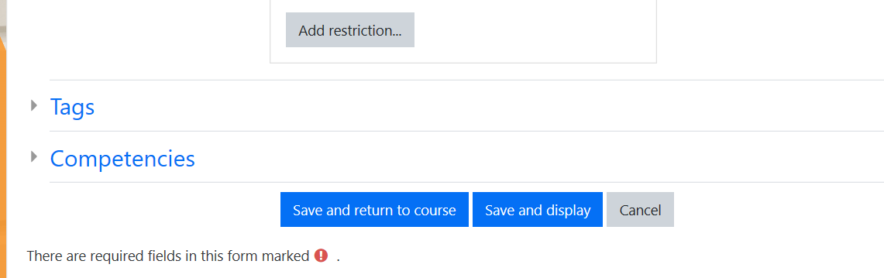
You have now successfully created your group and are able to join but clicking “Join session”
Once you have completed the above steps.
Click “Save and Display”
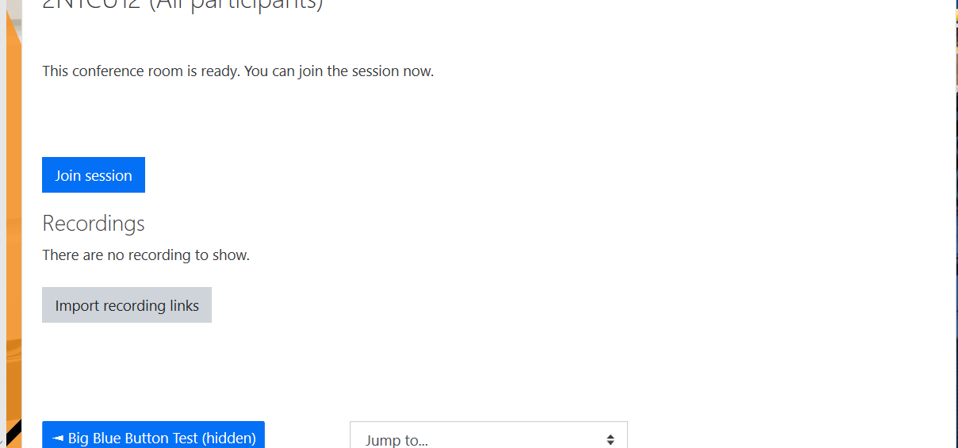
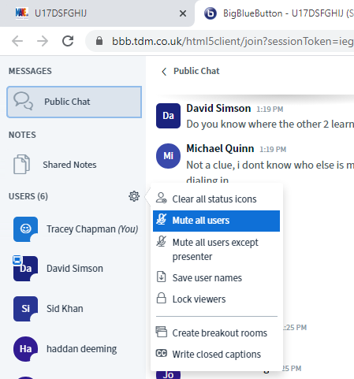
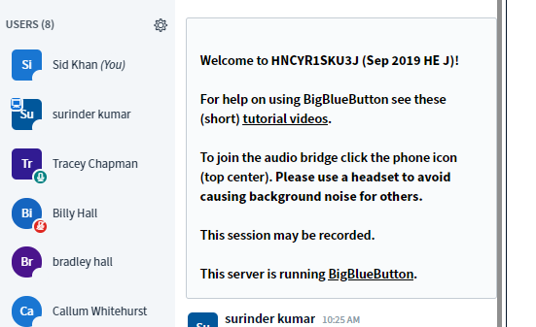
If you click on the settings icon you will be presented with this menu, if you click MUTE ALL USERS it will mute everyone. If you click MUTE ALL USERS EXCEPT PRESENTER you will only listen to the lecturer.
The learners can unmute themselves when they need to speak.
You can completely lock webcams and learner mics using LOCK VIEWERS
https://bigbluebutton.org/html5/
Please watch the videos on this link and make notes if needed.
The first thing you should do is watch the tutorial videos.
It’s a good idea to make sure all of your learners have watched the tutorial video at the beginning of the first lesson

